Central Okanagan Public Schools
Updated Restrictions for Cell Phones and Personal Digital Devices.
In accordance with the new requirements from the Ministry of Education and Child Care, schools across our district have updated their Student Code of Conduct to include the restricted use of cell phones and personal digital devices during school hours effective July 1, 2024.
Our School Code of Conduct has been revised to reflect the new requirements regarding cell phone use in schools accordingly. (Please include hyperlink to School Code of Conduct on your website)
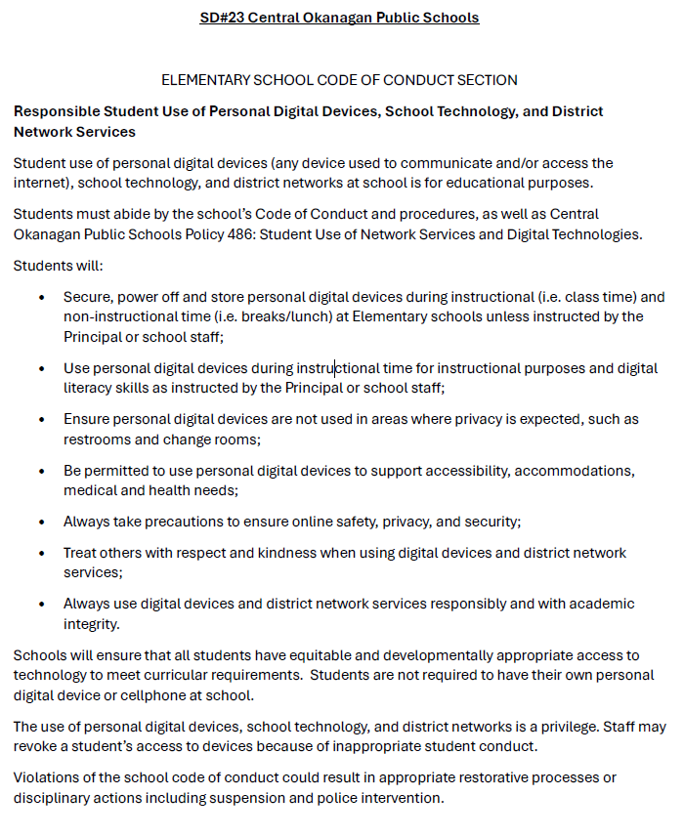
As part of our commitment to help our students develop digital citizenship, our educators will continue teaching our students how to use their personal digital devices and technology in a responsible and respectful way.
We ask that you support our staff and discuss these new restrictions with your child before the upcoming school year. If parents/caregivers need to contact their child during the school day, they should call the school office.
On a related note, the school is not responsible for lost, missing, or damaged personal digital devices that students choose to bring to school.
If you have questions or concerns, please contact your school’s administration.

